PowerMatcher Extension

Installation and Configuration

Authors:

A.H. Eisma (IBM)
C. Haverkamp (IBM)
Release: 0.9
Revision: 2
Date: 14-2-2013






Table of Contents
1. Introduction 5
2. PowerMatcher Extension overview 6
2.1 Components 6
2.2 Adapters 6
2.3 Run-time environments 6
3. PowerMatcher Extension component configuration 7
3.1 OSGi configuration example 7
3.1.1 Manual configuration using the web console 7
3.1.2 Configuration using XML 9
3.2 Stand-alone property file example 11
4. Additional Development environment setup for Extension 13
4.1 PowerMatcher maintenance versus application development 13
4.2 Lotus Expeditor Client installation 13
4.2.1 Installation on Windows 13
4.2.2 Installation on Linux 14
4.3 Retrieving the source code 14
4.4 IDE Setup 14
4.5 Importing the PowerMatcher Extension binary distribution 15
4.6 Importing the PowerMatcher Extension and Extension Example sources 16
4.7 Launching the example Extension applications from the workbench 16
4.7.1 Run the Extension example application as a stand-alone application 17
4.7.2 Run the MicroBroker Extension example application as a stand-alone application 17
4.7.3 Run the Extension example application as an OSGi application 17
4.7.4 Run the MicroBroker Extension example application as an OSGi application 17
4.8 Building a PowerMatcher Extension application 18
4.8.1 Build the stand-alone Extension example application 18
4.8.2 Build the PowerMatcher Extension OSGi bundle jars 18
5. Appendix A: PowerMatcher Extension Components 21
5.1 Extension components 21
5.1.1 Broker Manager 21
5.1.2 Micro broker bridge 21
5.1.3 Telemetry CSV Logging agent 22
5.2 Library components 22
5.2.1 Clipping Concentrator 22
5.2.2 Peak Shaving Concentrator 23
5.3 Extension Component Adapters 23
5.3.1 Direct Telemetry Adapter Factory 23
5.3.2 Telemetry Adapter Factory 23
5.3.3 Telemetry Listener Adapter Factory 24
5.3.4 MQTT v5 Connection Adapter Factory 24
6. Appendix B: OSGi runtime installation and setup 25
6.1.1 Install the required bundles 25
6.1.2 Install the application bundles 25
7. References 26

Table of Figures
Figure 1 Lotus Expeditor Client installation wizard start screen. 13
Figure 2 Lotus Expeditor Client installation wizard screen for changing setup defaults. 14
Figure 3 The 'cnf' project created by Bndtools prefilled with common bundles. 15
Figure 4 Add the MicroBroker jar files to the Bndtools repository. 15
Figure 5 Selecting the ‘Runnable JAR file’ option from the Eclipse Export wizard. 18
Figure 18 Build Core bundles using the Bndtools Release Bundles wizard. 19
Figure 6 Build all Extension bundles with the build.xml script in the OSGi example project. 19

Version History

Version | Description | Author
0.7 - 1 | Initial version for PowerMatcher release 0.7 | C. Haverkamp (IBM)
0.9 - 1 | Updated for PowerMatcher release 0.9 | A.H. Eisma (IBM)
0.9 – 2 | Updated for Bndtools 2.0 | A.H. Eisma (IBM)

Introduction
PowerMatcher Extension provides components and component adapters that extend the PowerMatcher Core component set. This document describes these additional components, how to configure and run them, and what is required to setup the development environment.

PowerMatcher Extension overview

Components
The set of PowerMatcher Core components [1] is extended with the following PowerMatcher Extension components:

- MicroBroker management agent
All communication between the components is done via a service bus using the MQTT-protocol. The MicroBroker management agent manages the creation of a MicroBroker MQTT bus. The agent supports different micro broker implementations.
- Telemetry CSV Logging agent
This agent subscribes to status and telemetry log messages and stores them in a comma separated file (csv-file).

Adapters
PowerMatcher Extension provides the following additional adapters:

- MQTT version 5 connection adapter
Messaging connections to the messaging bus of an MQTT broker are managed by MQTT connection adapter. PowerMatcher Core supports the open standard MQTTv3 protocol via the open source Eclipse Paho MQTTv3 client. PowerMatcher Extension also implements the MQTTv5 protocol, thereby supporting direct connections to IBM MicroBroker in the same runtime environment.
- Telemetry adapters
The capability of sending or receiving telemetry data is added to an agent by this component, either via a direct connection or via a messaging connection. Device agents can report telemetry and other measurement data via these adapters. The CSV logging agent can receive telemetry data using this adapter.

Run-time environments
The run-time environments are the same as described in the Core documentation [1]. In addition, PowerMatcher Extension provides components and adapters that support the MQTT Java broker and client libraries that are shipped with IBM Lotus Expeditor (a licensed product) [2].

PowerMatcher Extension component configuration
The Power Matcher runtime configuration as described in the PowerMatcher Core Installation and Configuration documentation [1] is be used to explain how to extend a PowerMatcher Core-based system configuration with components from the Extension library.

Instead of direct connections, we will now use messaging connections to an MQTT MicroBroker running in the same Java runtime. Note that this is primarily for the purpose of illustrating the use of messaging connections. In practice, direct connections are preferred over messaging connections when running in the same Java runtime. Changes and additions from the PowerMatcher Core example are shown in italics.

Component | Main component | Adapter
Broker | MicroBroker MQTT Broker Manager | .
Auctioneer | PowerMatcher Auctioneer | Market Basis adapter
Auctioneer | PowerMatcher Auctioneer | MQTTv3 or v5 Matcher adapter
Auctioneer | PowerMatcher Auctioneer | MQTTv3 or v5 Logging adapter, to csv logging agent
Concentrator | PowerMatcher Concentrator | MQTTv3 or v5 Protocol adapter, to auctioneer and objective agent
Concentrator | PowerMatcher Concentrator | MQTTv3 or v5 Matcher adapter
Concentrator | PowerMatcher Concentrator | MQTTv3 or v5 Logging adapter, to csv logging agent
Objective Agent | PowerMatcher Objective Agent | MQTTv3 or v5 Agent adapter, to auctioneer
Objective Agent | PowerMatcher Objective Agent | MQTTv3 or v5 Logging adapter, to csv logging agent
CSV Logging Agent | PowerMatcher CSV Logging Agent | MQTTv3 or v5 Log Listener adapter
CSV Logging Agent | PowerMatcher CSV Logging Agent | MQTTv3 or v5 Telemetry Listener adapter
Example Agent 3 | PowerMatcher Extension Example Agent 3 | MQTTv3 or v5 Agent adapter, to concentrator
Example Agent 3 | PowerMatcher Extension Example Agent 3 | MQTTv3 or v5 Logging adapter, to csv logging agent
Example Agent 3 | PowerMatcher Extension Example Agent 3 | MQTTv3 or v5 Telemetry adapter, to telemetry logging agent
*all* |  | Time and scheduler adapter

Table 1 The components and component adapters for a PowerMatcher Extension application
In the configuration examples an MQTT version 5 connection adapter will be used. However, a version 3 connection adapter can be used as well.

In this chapter we will illustrate, just as for PowerMatcher Core, the creation of a basic PowerMatcher runtime using the following alternate approaches:
- Create a configuration manually using the OSGi web console.
- Configuration of an OSGi runtime using an XML configuration file.
- Configuration of a standard Java runtime using a properties file.

OSGi configuration example

Manual configuration using the web console
Using the Apache Felix Web Console the configuration can be created manually. Each configuration object for a component that is created with the web console is already prefilled with the default values. However, in this example we will not use the default direct connection adapters, so creating the configuration by hand is more involved.

Open the Apache Felix Web Console (http://localhost:8080/system/console). Then navigate to the Configuration tab and find the configuration name as listed in the table. Click the ‘+’ to create a new configuration instance or edit a single configuration instance (e.g. for the Auctioneer) and fill in the properties as specified in the table. Select the Save button to create the configuration.
Component | Required OSGi configurations (name/class name) | Set property
Time Adapter | PowerMatcher Time Adapter Factory /  net.powermatcher.core.scheduler.TimeAdapterFactory | Accept all default values
Scheduler Adapter | PowerMatcher Scheduler Adapter Factory /  net.powermatcher.core.scheduler.SchedulerAdapterFactory | Accept all default values
Agent Adapter | PowerMatcher Agent Protocol Adapter /  net.powermatcher.core.messaging.protocol.adapter.  AgentProtocolAdapterFactory | Id: agentAdapterFactory  Messaging adapter factory: mqttv5ConnectionFactory
Matcher Adapter | PowerMatcher Matcher Protocol Adapter /  net.powermatcher.core.messaging.protocol.adapter.  MatcherProtocolAdapterFactory | Id: matcherAdapterFactory  Messaging adapter factory: mqttv5ConnectionFactory
Logging Adapter | PowerMatcher Logging Adapter /  net.powermatcher.core.messaging.protocol.adapter.  LoggingAdapterFactory | Id: loggingAdapterFactory  Messaging adapter factory: mqttv5ConnectionFactory
Log Listener Adapter | PowerMatcher Log Listener Adapter /  net.powermatcher.core.messaging.protocol.adapter.  LogListenerAdapterFactory | Id: logListenerAdapterFactory  Messaging adapter factory: mqttv5ConnectionFactory
Telemetry Adapter | Telemetry Adapter /  net.powermatcher.telemetry.messaging.protocol.adapter.TelemetryListenerAdapterFactory | Id: telemetryAdapterFactory  Messaging adapter factory: mqttv5ConnectionFactory
Telemetry Listener Adapter | Telemetry Listener Adapter /  net.powermatcher.telemetry.messaging.protocol.adapter.TelemetryAdapterFactory | Id: telemetryListenerAdapterFactory  Messaging adapter factory: mqttv5ConnectionFactory
Market Basis Adapter | PowerMatcher Market Basis Adapter /  net.powermatcher.core.agent.marketbasis.adapter. MarketBasisAdapterFactory | Accept all default values
MQTTv5 Adapter | MQTTv5 Connection Adapter /  net.powermatcher.expeditor.messaging.mqttv5.  Mqttv5ConnectionFactory | Accept all default values
Auctioneer | PowerMatcher Auctioneer /  net.powermatcher.core.agent.auctioneer.Auctioneer | Id: auctioneer  Matcher factory id: matcherAdapterFactory  Logging factory id: loggingAdapterFactory
Concentrator | PowerMatcher Concentrator /  net.powermatcher.core.agent.concentrator.Concentrator | Id: concentrator  Matcher id: auctioneer  Agent factory id: agentAdapterFactory  Matcher factory id: matcherAdapterFactory  Logging factory id: loggingAdapterFactory
Objective Agent | PowerMatcher Objective Agent /  net.powermatcher.core.agent.objective.ObjectiveAgent | Id: objectiveagent  Matcher id: auctioneer  Objective bid: (64,0);(64,-1000.0)  Agent factory id: agentAdapterFactory  Matcher factory id: matcherAdapterFactory  Logging factory id: loggingAdapterFactory
CSV Logging Agent | PowerMatcher CSV logging Agent /  net.powermatcher.core.agent.logging.CSVLoggingAgent | Id: csvlogging  Log listener factory id: logListenerAdapterFactory
Telemetry CSV Logging Agent | Telemetry CSV logging Agent /  net.powermatcher.agent.telemetry.logging.TelemetryCSVLoggingAgent | Id: telemetrylogging  Telemetry listener factory id: telemetryListenerAdapterFactory
Test Agent | PowerMatcher Test Agent /  net.powermatcher.core.agent.test. TestAgent | Id: testagent1  Matcher id: concentrator  Agent factory id: agentAdapterFactory  Logging factory id: loggingAdapterFactory
Example Agent 3 | PowerMatcher Example Agent 3 /  net.powermatcher.agent.template.ExampleAgent3 | Id: exampleagent3  Matcher id: concentrator  Agent factory id: agentAdapterFactory  Logging factory id: loggingAdapterFactory  Telemetry factory id: telemetryAdapterFactory
Table 2 Component properties to be defined in the web console for an Extension configuration.

Configuration using XML
This section describes how to extend the Core configuration with Extension components using XML configuration. The properties that must be defined for the example of Table 2 are shown in Table 3. In this table common adapter factory properties have been omitted; these are defined as global properties in the XML below.
Component | Required OSGi configurations (name/class name) | Set property
Time Adapter | PowerMatcher Time Adapter Factory /  net.powermatcher.core.scheduler.TimeAdapterFactory | id: timeAdapterFactory
Scheduler Adapter | PowerMatcher Scheduler Adapter Factory /  net.powermatcher.core.scheduler.SchedulerAdapterFactory | id: schedulerAdapterFactory
Agent Adapter | PowerMatcher Agent Protocol Adapter /  net.powermatcher.core.messaging.protocol.adapter.  AgentProtocolAdapterFactory | id: agentAdapterFactory
Matcher Adapter | PowerMatcher Matcher Protocol Adapter /  net.powermatcher.core.messaging.protocol.adapter.  MatcherProtocolAdapterFactory | id: matcherAdapterFactory
Logging Adapter | PowerMatcher Logging Adapter /  net.powermatcher.core.messaging.protocol.adapter.  LoggingAdapterFactory | id: loggingAdapterFactory
Log Listener Adapter | PowerMatcher Log Listener Adapter /  net.powermatcher.core.messaging.protocol.adapter.  LogListenerAdapterFactory | id: logListenerAdapterFactory
Telemetry Adapter | Telemetry Adapter /  net.powermatcher.telemetry.messaging.protocol.adapter.TelemetryListenerAdapterFactory | id: telemetryAdapterFactory
Telemetry Listener Adapter | Telemetry Listener Adapter /  net.powermatcher.telemetry.messaging.protocol.adapter.TelemetryAdapterFactory | id: telemetryListenerAdapterFactory
Market Basis Adapter | PowerMatcher Market Basis Adapter /  net.powermatcher.core.agent.marketbasis.adapter. MarketBasisAdapterFactory | id: marketBasisAdapterFactory
MQTTv5 Adapter | MQTTv5 Connection Adapter /  net.powermatcher.expeditor.messaging.mqttv5.  Mqttv5ConnectionFactory | id: mqttv5ConnectionFactory
Auctioneer | PowerMatcher Auctioneer /  net.powermatcher.core.agent.auctioneer.Auctioneer | id: auctioneer
Concentrator | PowerMatcher Concentrator /  net.powermatcher.core.agent.concentrator.Concentrator | id: concentrator  matcher.id : auctioneer
Objective Agent | PowerMatcher Objective Agent /  net.powermatcher.core.agent.objective.ObjectiveAgent | id: objectiveagent  matcher.id: auctioneer  objective.bid: (64,0);(64,-1000.0)
CSV Logging Agent | PowerMatcher CSV logging Agent /  net.powermatcher.core.agent.logging.CSVLoggingAgent | id: csvlogging  log.listener.adapter.factory: logListenerAdapterFactory
Telemetry CSV Logging Agent | Telemetry CSV logging Agent /  net.powermatcher.agent.telemetry.logging.TelemetryCSVLoggingAgent | id: telemetrylogging  telemetry.listener.adapter.factory : telemetryListenerAdapterFactory
Test Agent | PowerMatcher Test Agent /  net.powermatcher.core.agent.test. TestAgent | id: testagent1  matcher.id: concentrator
Example Agent 3 | PowerMatcher Example Agent 3 /  net.powermatcher.agent.template.ExampleAgent3 | id: exampleagent3  matcher.id: concentrator
Table 3 Component properties to be defined in XML for a PowerMatcher runtime with Extension components.

In the following example all component and adapter factory configurations of Table 3 have been included in the XML. Note that factory ids must be specified explicitly and have been defined as global properties for the commonly used factories.

<?xml version="1.0" encoding="UTF-8"?>
<nodeconfig id="sample_node" name="Sample Extension node"
description="Example PWM Extension configuration using XML." date="2012-06-01">
<property name="time.adapter.factory" value="timeAdapterFactory" type="String"/>
<property name="scheduler.adapter.factory" value="schedulerAdapterFactory" type="String"/>
<property name="agent.adapter.factory" value="aqentAdapterFactory" type="String"/>
<property name="matcher.adapter.factory" value="matcherAdapterFactory" type="String"/>
<property name="logging.adapter.factory" value="loggingAdapterFactory" type="String"/>
<property name="messaging.adapter.factory" value="mqttv5ConnectionFactory" type="String"/>
<property name="log.listener.id" value="csvlogging" type="String"/>
<configuration type="singleton" cluster="DemoPwmExt"
pid="net.powermatcher.expeditor.broker.manager.BrokerManager" id="MicroBroker">
<property name="broker.name" value="MicroBroker" type="String" />
</configuration>
<configuration type="factory" cluster="DemoPwmExt"
pid="net.powermatcher.core.agent.auctioneer.Auctioneer" id="auctioneer">
<property name="id" value="auctioneer" type="String"/>
<property name="agent.adapter.factory" value="marketBasisAdapterFactory" type="String"/>
</configuration>
<configuration type="factory" cluster="DemoPwmExt"
pid="net.powermatcher.core.agent.concentrator.Concentrator"
id="concentrator">
<property name="id" value="concentrator" type="String"/>
<property name="matcher.id" value="auctioneer" type="String"/>
</configuration>
<configuration type="factory" cluster="DemoPwmExt"
pid="net.powermatcher.core.agent.objective.ObjectiveAgent"
id="concentrator">
<property name="id" value="objectiveagent" type="String"/>
<property name="matcher.id" value="objectiveagent" type="String"/>
<property name="objective.bid" value="(64,0);(64,-1000.0)" type="String"/>
</configuration>
<configuration type="factory" cluster="DemoPwmExt"
pid="net.powermatcher.core.agent.logging.CSVLoggingAgent"
id="csvlogging">
<property name="id" value="csvlogging" type="String"/>
<property name="log.listener.adapter.factory" value="logListenerAdapterFactory" type="String"/>
</configuration>
<configuration type="factory" cluster="DemoPwmExt"
pid="net.powermatcher.agent.telemetry.logging.TelemetryCSVLoggingAgent"
id="telemetrylogging">
<property name="id" value="telemetrylogging" type="String"/>
<property name="telemetry.listener.adapter.factory" value="telemetryListenerAdapterFactory" type="String"/>
</configuration>
<configuration type="factory" cluster="DemoPwmExt"
pid="net.powermatcher.core.agent.test.TestAgent"
id="testagent1">
<property name="id" value="testagent1" type="String"/>
<property name="matcher.id" value="concentrator" type="String"/>
</configuration>
<configuration type="factory" cluster="DemoPwmExt"
pid="net.powermatcher.agent.template.ExampleAgent3"
id="exampleagent1">
<property name="id" value="exampleagent1" type="String"/>
<property name="matcher.id" value="concentrator" type="String"/>
<property name="telemetry.listener.id" value="telemetrylogging" type="String"/>
<property name="telemetry.adapter.factory" value="telemetryAdapterFactory" type="String"/>
</configuration>
<configuration type="factory" cluster="DemoPwmExt"
pid="net.powermatcher.core.scheduler.TimeAdapterFactory"
id="timeAdapter">
<property name="id" value="timeAdapterFactory" type="String"/>
</configuration>
<configuration type="factory" cluster="DemoPwmExt"
pid="net.powermatcher.core.scheduler.SchedulerAdapterFactory"
id="schedulerAdapter">
<property name="id" value="schedulerAdapterFactory" type="String"/>
</configuration>
<configuration type="factory" cluster="DemoPwmExt"
pid="net.powermatcher.core.messaging.protocol.adapter.AgentProtocolAdapterFactory"
id="agentProtocolAdapter">
<property name="id" value="agentProtocolAdapterFactory" type="String"/>
</configuration>
<configuration type="factory" cluster="DemoPwmExt"
pid="net.powermatcher.core.messaging.protocol.adapter.MatcherProtocolAdapterFactory"
id="matcherProtocolAdapter">
<property name="id" value="matcherProtocolAdapterFactory" type="String"/>
</configuration>
<configuration type="factory" cluster="DemoPwmExt"
pid="net.powermatcher.core.messaging.protocol.adapter.LoggingProtocolAdapterFactory"
id="loggingProtocolAdapter">
<property name="id" value="loggingProtocolAdapterFactory" type="String"/>
</configuration>
<configuration type="factory" cluster="DemoPwmExt"
pid="net.powermatcher.core.messaging.protocol.adapter.LogListenerProtocolAdapterFactory"
id="logListenerProtocolAdapter">
<property name="id" value="logListenerProtocolAdapterFactory" type="String"/>
</configuration>
<configuration type="factory" cluster="DemoPwmExt"
pid="net.powermatcher.telemetry.messaging.protocol.adapter.TelemetryAdapterFactory"
id="telemetrydapter">
<property name="id" value="telemetryAdapterFactory" type="String"/>
</configuration>
<configuration type="factory" cluster="DemoPwmExt"
pid="net.powermatcher.telemetry.messaging.protocol.adapter.TelemetryListenerAdapterFactory"
id="telemetryListenerAdapter">
<property name="id" value="telemetryListenerAdapterFactory" type="String"/>
</configuration>
<configuration type="factory" cluster="DemoPwmExt"
pid="net.powermatcher.core.agent.marketbasis.adapter.MarketBasisAdapterFactory"
id="marketBasisAdapter">
<property name="id" value="marketBasisAdapterFactory" type="String"/>
</configuration>
<configuration type="factory" cluster="DemoPwmExt"
pid="net.powermatcher.expeditor.messaging.mqttv5.Mqttv5ConnectionFactory"
id=" mqttv5ConnectionFactory">
<property name="id" value="mqttv5ConnectionFactory" type="String"/>
<property name="broker.uri" value="tcp://localhost:1883" type="String" />
</configuration>
</nodeconfig>

Stand-alone property file example
In order to create a stand-alone Java PowerMatcher environment similar to the environments created using the Apache Felix Web console and the XML configuration for the OSGi runtime, the same definitions as listed in Table 3 should be added to a properties file.

By default, PowerMatcher expects the properties file name ‘agent_config.properties’ in the same directory as the directory from where the application is started. It is possible to specify an alternative properties file path as described in section Error: Reference source not found.The properties from Table 3 can be specified as follows in a properties file:

# Global properties.
cluster.id=DemoPwmExt
# By default logging will go to the configured CSVLoggingAgent agent.
log.listener.id=csvlogging
# By default telemetry will go to the configured TelemetryCSVLoggingAgent agent.
telemetry.listener.id=telemetrycsvlogging

# Define time & scheduler adapter factories
adapter.factory.timeAdapterFactory.class=net.powermatcher.core.scheduler.TimeAdapterFactory
adapter.factory.schedulerAdapterFactory.class=net.powermatcher.core.scheduler.SchedulerAdapterFactory

# Define adapter factories for message broker connections
adapter.factory.agentAdapterFactory.class=net.powermatcher.core.messaging.protocol.adapter.AgentProtocolAdapterFactory
adapter.factory.agentAdapterFactory.agent.messaging.protocol=INTERNAL_v1
adapter.factory.matcherAdapterFactory.class=net.powermatcher.core.messaging.protocol.adapter.MatcherProtocolAdapterFactory
adapter.factory.matcherAdapterFactory.matcher.messaging.protocol=INTERNAL_v1
adapter.factory.loggingAdapterFactory.class=net.powermatcher.core.messaging.protocol.adapter.LoggingAdapterFactory
adapter.factory.logListenerAdapterFactory.class=net.powermatcher.core.messaging.protocol.adapter.LogListenerAdapterFactory
adapter.factory.telemetryAdapterFactory.class=net.powermatcher.telemetry.messaging.protocol.adapter.TelemetryAdapterFactory
adapter.factory.telemetryListenerAdapterFactory.class=net.powermatcher.telemetry.messaging.protocol.adapter.TelemetryListenerAdapterFactory
adapter.factory.mqttv5ConnectionFactory.class=net.powermatcher.expeditor.messaging.mqttv5.Mqttv5ConnectionFactory

# Default scheduler adapter factories
time.adapter.factory=timeAdapterFactory
scheduler.adapter.factory=schedulerAdapterFactory

# Default adapter factories for message broker connections
agent.adapter.factory=agentAdapterFactory
matcher.adapter.factory=matcherAdapterFactory
logging.adapter.factory=loggingAdapterFactory
log.listener.adapter.factory=logListenerAdapterFactory
telemetry.adapter.factory=telemetryAdapterFactory
telemetry.listener.adapter.factory=telemetryListenerAdapterFactory
messaging.adapter.factory=mqttv5ConnectionFactory

# Auctioneer properties
agent.auctioneer.class=net.powermatcher.core.agent.auctioneer.Auctioneer
agent.auctioneer.id=auctioneer
agent.auctioneer1.agent.adapter.factory=marketBasisAdapterFactory

# Concentrator properties
agent.concentrator.class=net.powermatcher.core.agent.concentrator.Concentrator
agent.concentrator.id=concentrator
agent.concentrator.matcher.id=auctioneer

# ObjectiveAgent properties
agent.objectiveagent.class=net.powermatcher.core.agent.objective.ObjectiveAgent
agent.objectiveagent.id=objectiveagent
agent.objectiveagent.matcher.id=auctioneer
agent.objectiveagent.objective.bid=(64,0);(64,-1000.0)

# CSVLoggingAgent properties
agent.csvlogging.class=net.powermatcher.core.agent.logging.CSVLoggingAgent
agent.csvlogging.id=csvlogging

# TelemetryCSVLoggingAgent properties
agent.telemetrycsvlogging.class=net.powermatcher.agent.telemetry.logging.TelemetryCSVLoggingAgent
agent.telemetrycsvlogging.id=telemetrycsvlogging
agent.telemetrycsvlogging.enabled=true

# Test Agent 1
agent.testagent1.class=net.powermatcher.core.agent.test.TestAgent
agent.testagent1.id=testagent1
agent.testagent1.matcher.id=concentrator

# Example Agent 3
agent.testagent1.class=net.powermatcher.agent.template.ExampleAgent3
agent.testagent1.id=exampleagent3
agent.testagent1.matcher.id=concentrator

Additional Development environment setup for Extension
Set setup of an Eclipse IDE for PowerMacher Core has been described in the Core Installation and Configuration document [1]. This chapter describes the additional setup that is required for development with PowerMatcher Extension components. The pattern is the

PowerMatcher maintenance versus application development

There are two different configurations for the PowerMatcher Core and Extension development environment.
- The development environment for the Core and Extension agent and application developer.
This environment contains the Core and Extension Example template source code projects and uses the binary distribution of the PowerMatcher Core and Extension libraries and bundles.
- The development environment for the PowerMatcher Core and Extension developer, for maintaining and extending the PowerMatcher Core and Extension code base.
This environment uses all Core, Core Example, Extension and Extension Example source code projects as well as the binary distribution of the PowerMatcher Core and Extension libraries and bundles.

Lotus Expeditor Client installation
A subset of the PowerMatcher Extension source code, the net.powermatcher.expeditor projects, requires that you have the Java MicroBroker libraries installed on your system. MicroBroker is shipped with IBM Lotus Expeditor Client 6.2.3, a commercial product that requires a license [2]. Install the Lotus Expeditor Client on the Windows or Linux development workstation and accept the default installation paths. The default installation path is referenced in the Eclipse User Library definition that you will import in a later step.

After installation the following MicroBroker libraries are available as part of the IBM Lotus Expeditor Client installation:

- com.ibm.micro-3.0.2.jar (com.ibm.micro_3.0.3.0-20110708.jar)
- com.ibm.micro.admin-3.0.3 (com.ibm.micro.admin_3.0.3.0-20110708.jar)
- com.ibm.micro.client-3.0.2 (com.ibm.micro.client_3.0.3.0-20110708.jar)
- com.ibm.mqttclient-3.0.2 (com.ibm.mqttclient_3.0.3.0-20110708.jar)
- com.ibm.micro.utils-3.0.2 (com.ibm.micro.utils_3.0.3.0-20110708.jar)
- com.ibm.micro.utils.extended-3.0.2 (com.ibm.micro.utils.extended_3.0.3.0-20110708.jar).

Installation on Windows
For installation of Lotus Expeditor Client version 6.2.3 on Windows start the setupwin32.exe in the ‘desktop’ folder of the Client installation CD. Accept the default installation path and click next.

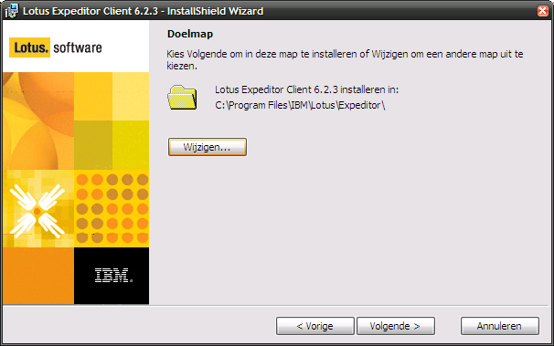
Figure 1 Lotus Expeditor Client installation wizard start screen.

Accept in the next screen the defaults (only install Expeditor Client) and click next.

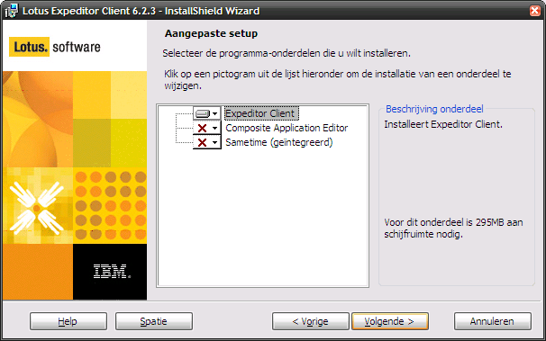
Figure 2 Lotus Expeditor Client installation wizard screen for changing setup defaults.

Finally click Install to start the installation.

The library files for MicroBroker can be found after installation of Lotus Expeditor Client in the following directory:

C:\Program Files (x86)\IBM\Lotus\Expeditor\rcp\eclipse\plugins

or, for win32:

C:\Program Files\IBM\Lotus\Expeditor\rcp\eclipse\plugins

The Lotus Expeditor Client installation also includes an IBM JRE which can be found in the following directory:

C:\Program Files (x86)\IBM\Lotus\Expeditor\rcp\eclipse\\com.ibm.rcp.j2se.win32.x86_1.6.0.20110714a-201108151128

or, for win32:

C:\Program Files\IBM\Lotus\Expeditor\rcp\eclipse\plugins\com.ibm.rcp.j2se.win32.x86_1.6.0.20110714a-201108151128

Installation on Linux
For installation of Lotus Expeditor Client version 6.2.3 on Linux, install the expeditor-6.2.3-201109020733.i586.rpm or expeditor-6.2.3-201109020733_i386.deb package in the ‘desktop’ folder of the Client installation CD.

The library files for MicroBroker can be found after installation of Lotus Expeditor Client in the following directory:

/opt/ibm/lotus/Expeditor/rcp/eclipse/plugins

The Lotus Expeditor Client installation also includes an IBM JRE which can be found in the following directory:

/opt/ibm/lotus/Expeditor/rcp/eclipse/plugins/com.ibm.rcp.j2se.win32.x86_1.6.0.20110714a-201108151128

Retrieving the source code

The source code of PowerMatcher Core is delivered as an Eclipse project archive compressed in ZIP format. Download the PowerMatcher Extension zip file from the PowerMatcher download site.

Unzip the file to a directory and remember the location for the next steps.

IDE Setup

Start Eclipse and open the workspace that contains a workspace with the PowerMatcher Core sources.
This workspace should also contain the ‘cnf’ project that was created by Bndtools. This project contains the bundle repository.

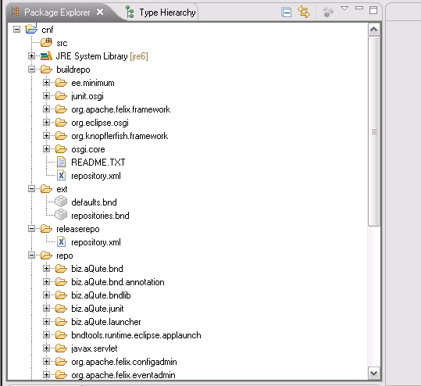
Figure 3 The 'cnf' project created by Bndtools prefilled with common bundles.

The MicroBroker bundles need to be added to the Bndtools Local repository. In the Bndtools perspective, navigate to the Repositories view and select Local repository. Click the icon of the ‘Add bundles to repository’ and add the jar files listed in paragraph 4.1, or drag and drop the files on the Local repository entry:

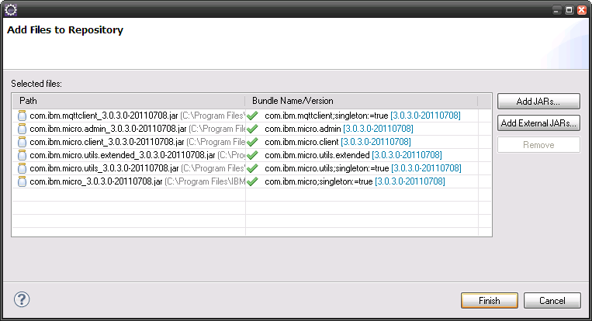
Figure 4 Add the MicroBroker jar files to the Bndtools repository.

Importing the PowerMatcher Extension binary distribution
This step is required for both the agent developer workspace, as well as for the workspace for PowerMatcher maintenance. In this step a new Bndtools local repository is added to the workspace that will contain the PowerMatcher Extension bundle library jars.

- Create workspace folders /cnf/extrepo and /cnf/agentrepo.
- Edit /cnf/ext/repositories.bnd and insert the following two lines to add two new repositories labeled ‘Extension’ and ‘Agent’:
aQute.bnd.deployer.repository.LocalIndexedRepo; name=Extension; local=${workspace}/cnf/extrepo;pretty=true,\
aQute.bnd.deployer.repository.LocalIndexedRepo; name=Agent; local=${workspace}/cnf/agentrepo;pretty=true,\
- Add all PowerMatcher Extension and Agent bundle jars to the Extension repository by dragging and dropping the jars on ‘Extension’ and ‘Agent’ in the Repositories View.

Importing the PowerMatcher Extension and Extension Example sources

The source projects can now be imported into the workspace. First switch off the automatic build option by de-selecting ‘Build automatically…’ in the Project menu. Then use the Import… wizard and select ‘Import existing projects into workspace’ and point the wizard to the folder where you exported the project archive file. Select all projects and check ‘Copy projects into workspace’ and import the projects by clicking the Finish button.

Before the sources can be successfully compiled a ‘user library’ for MicroBroker needs to be created. The user library settings are stored in a file and can be imported via the Eclipse Preferences window:

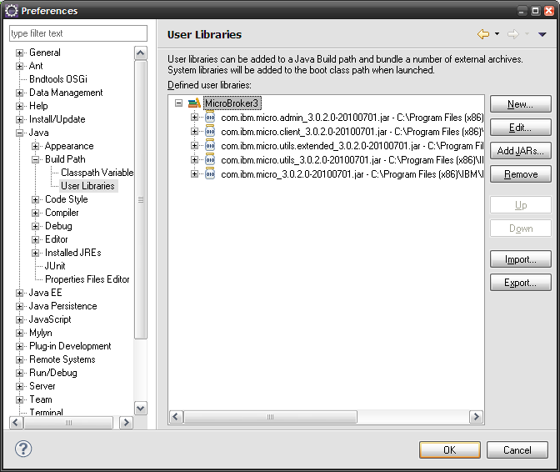

The user library definition file for the MicroBroker libraries is located in the net.powermatcher.expeditor.launcher.mbroker.template project and is named ‘PowerMatcher MicroBroker Extension.userlibraries’. The import will create the MicroBroker3 user library that references the MicroBroker library files in the Bndtools cnf directory. Click on the ‘Import…’ button in the User Libraries section in the Preferences window.

There is another user library pre-defined that is required for projects that use Telemetry features provided by PowerMatcher Extension. Import the file ‘PowerMatcher Extension.userlibraries’ that is located in project net.powermatcher.extension.launcher.main.template. This will create the PowerMatcher Extension user library.

After the import completed restart the workbench (File -> Restart). The cnf repository cache of BND tools will now be cleared. From the message bar at the bottom of the window you can see when this task is running. If the task is completed check the ‘Build automatically…’ option or hit Ctrl-B (i.e. Build All). All projects should now compile successfully.

Launching the example Extension applications from the workbench
This paragraph describes how to run the example PowerMatcher applications that contain Extension components, from the development workbench in Eclipse. There will be two options: running a stand-alone application and running it within OSGi.

Run the Extension example application as a stand-alone application
The PowerMatcher Extension stand-alone application is an example application that contains PowerMatcher Extension components. This example depends on an external broker. Because a broker is required, an external broker needs to be started first, using one of the following two options:
- Start the open source Mosquitto broker as explained in the PowerMatcher Core Installation and Configuration manual.
- Use the ‘Standalone MicroBroker Launch’ Eclipse launch configuration that is contributed by the net.powermatcher.expeditor.launcher.mbroker project. This launch configuration starts MicroBroker as a standard Java application, using the configuration properties defined in file broker_config.properties.

When the broker is running, the example application can be started with the launch configuration named ‘PowerMatcher Extension Launch Template’ from project net.powermatcher.extension.launcher.main.template.

Run the MicroBroker Extension example application as a stand-alone application
The MicroBroker Extension example application located in the project net.powermatcher.expeditor.launcher.mbroker.template contains an example of a launch configuration that starts both a PowerMatcher application and MicroBroker in the same Java runtime. This launch configuration also uses the configuration properties defined in file broker_config.properties to configure the broker.

The example application can be started with the launch configuration named ‘PowerMatcher Launch with MicroBroker Template.launch’ from project net.powermatcher.expeditor.launcher.mbroker.template.

Run the Extension example application as an OSGi application
The PowerMatcher Extension OSGi example application contains PowerMatcher Extension components and runs in an OSGi run-time environment. This example depends on an external broker. Because a broker is required, an external broker needs to be started first, using one of the following two options:
- Start the open source Mosquitto broker as explained in the PowerMatcher Core Installation and Configuration manual.
- Use the ‘Standalone MicroBroker Launch’ Eclipse launch configuration that is contributed by the net.powermatcher.expeditor.launcher.mbroker project. This launch configuration starts MicroBroker as a standard Java application, using the configuration properties defined in file broker_config.properties.

When the broker is running, the example application can be started with the Bndtools run configuration named ‘PowerMatcher OSGi Launch Example Template.bndrun’ from project net.powermatcher.extension.launcher.osgi.template.

Run the MicroBroker Extension example application as an OSGi application
The PowerMatcher MicroBroker Extension OSGi example application contains PowerMatcher Extension components, including the MicroBroker Management Agent, and runs in an OSGi run-time environment. The MicroBroker Management Agent starts a MicroBroker instance as defined in example_extension_config.xml.

The example application can be started with the Bndtools run configuration named ‘PowerMatcher OSGi Launch MBroker Example Template.bndrun’ from project net.powermatcher.expeditor.launcher.osgi.template.

This is the preferred configuration for running a PowerMatcher component in a distributed environment because it is possible to define bridging of topics between distributed brokers from the configuration XML.

Building a PowerMatcher Extension application

Build the stand-alone Extension example application
Make sure the source code is compiled by verifying if the option ‘Build Automatically’ is checked in the Project menu. If not check the option and verify the compilation progress in the status bar at the bottom of the window.

From the File menu select Export… menu option. The Export dialog will appear.
Select the item Java>Runnable JAR and hit next:
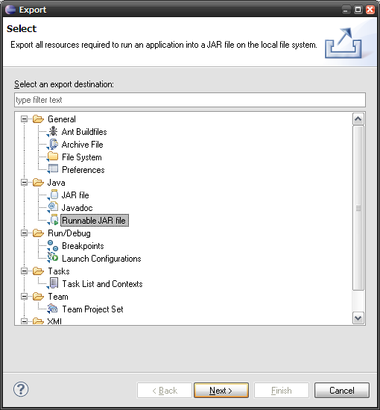
Figure 5 Selecting the ‘Runnable JAR file’ option from the Eclipse Export wizard.

The page ‘Runnable JAR file export’ will appear. Select the launch configuration ‘PowerMatcher Extension Launch Template’ and type the export destination (for example c:\export\exampleapp.jar). The option ‘Copy required libraries into a sub-folder next to the generated JAR’ will create an exampleapp_lib directory containing the required libraries.

The application needs also the logback.xml and the agent_config.properties. Copy these files from the net.powermatcher.extension.launcher.main.template project to the build directory.

Build the PowerMatcher Extension OSGi bundle jars
If you run a PowerMatcher OSGi application from the workspace, the launch configurations have been set up to use the bundle jars located in the ‘generated’ directory of the projects. Besides building and releasing individual bundles using the Bndtools Release Bundle wizard on the bnd.bnd file in a bundle project, it is also possible to build all bundles using an Ant script for PowerMatcher Extension.

Note that when running a PowerMatcher application as a standard Java application, the library jars from the Bndtools Core and Extension repositories are referenced though the Eclipse User Library definitions. In this case the jars located in the ‘generated’ directory of the projects will not be used.

Bndtools provides two ways to build OSGi bundles for deployment and release. Since Bndtools 2.0 the built-in Release Bundles wizard can be used to build and release a single or multiple bundles in one step. Alternatively, the Bndtools Ant build scripts can be used as explained below. However, this is much more involved.

To build the Extension or Agent bundles using the Release Bundles wizard, select one or more projects, or select the working set containing all projects, and select Release Bundles from the context menu. By default, the wizard releases all bundles to the Release repository, as shown in the following figure.

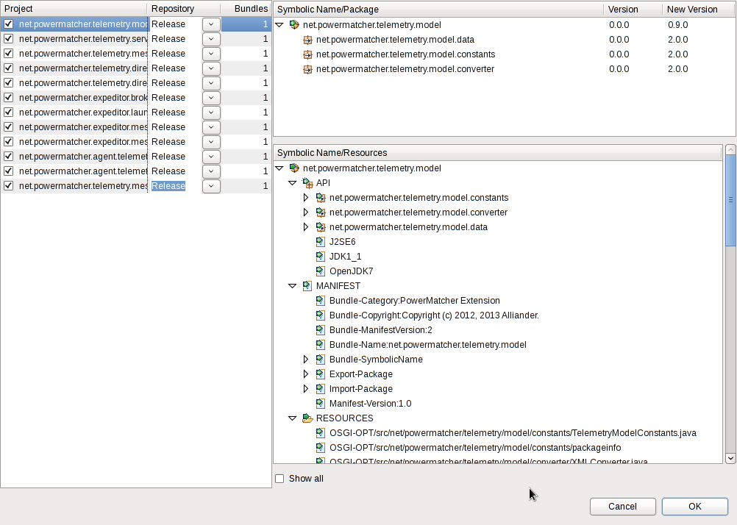
Figure 6 Build Core bundles using the Bndtools Release Bundles wizard.
To build and release the bundles to a different repository, change the –releaserepo setting in /cnf/ext/repositories.bnd to Extension or Agent.

The build and release using Ant requires a workspace that does not contain the PowerMatcher Core and Core Example projects, but only the PowerMatcher Core and Core Example binary distribution. The reason is that the Bndtools Ant build script builds dependent projects recursively, which would result in a release of the rebuilt Core bundles into the Extension repository.

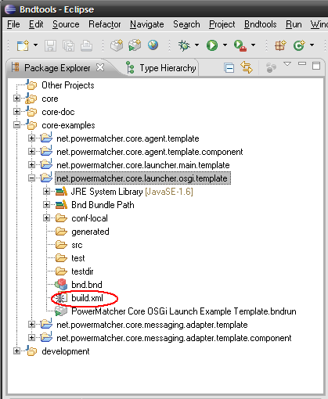
Figure 7 Build all Extension bundles with the build.xml script in the OSGi example project.

The build and release using Ant is started by selecting the build.xml file en choosing “Run As > ANT Build…”. The default Ant target is ‘build’. To update the bundles in the Bndtools Extension or Agent repository in the workspace, the ‘release’ target must be selected and the –releaserepo setting in /cnf/ext/repositories.bnd must be set to Extension.

All PowerMatcher Extension, Extension Example and Agent bundles are built through the Ant build.xml file in the net.powermatcher.extension.resource project. Individual bundles can be built and released via Run As > Ant Build on the build.xml in a bundle project.

Note that the build and release may take a considerable amount of time. The reason is that for each bundle references, Bndtools rebuilds and releases all prerequisite bundles recursively.

After the build completes, the released Agent bundles can be moved from /cnf/extrepo to /cnf/agentrepo. The Eclipse workspace must be restarted after moving bundles in cnf for Bndtools to update its indices.

Appendix A: PowerMatcher Extension Components

Extension components
This section describes the extension components, their configuration properties and the dependencies.

Broker Manager
The Broker Manager component creates and starts a broker. This is a singleton component, which means that at most only once broker can be configured in the runtime.

Component: Broker Manager |  |  |  | Type: singleton component
Class: net.powermatcher.expeditor.broker.manager.BrokerManager
Dependencies:
Microbroker libararies
Property | Type | Req. | Default | Description
broker.name | String | N | MicroBroker | MicroBroker instance name. A directory with the same name will be created to store MicroBroker data.
microbroker.dir | String | N | DefaultCluster | Directory where the MicroBroker data directory will be created.
microbroker.maxMessageSize | int | N | 100 | Maximum message size that is allowed on the created MQTT bus.
microbroker.maxNumberOfClients | int | N | -1 | Maximum number of clients (-1 is no limit).
microbroker.numberOfLogFilesToKeep | int | N | 10 | Maximum number of log files to keep.
microbroker.persistence | int | N | 0 | Persist the messages on topics and queues.
microbroker.port | int | N | 1883 | MicroBroker port.
microbroker.queueSize | int | N | 0 | Message queue size.
microbroker.waitTimeout | long | N | 10000 | Timeout.

Security is enabled by default if JAAS is supported in the Java runtime environment. Anonymous connections are permitted by default. Local authentication requires customization of the default 'acl'-file that is generated when a new broker is started and requires a custom JAAS authentication module. This is out of scope for this document.

Micro broker bridge
The MicroBroker bridge or Pipe is used to connect two MQTT brokers by defining the topic patterns that are bridged from (outbound) and to (inbound) this broker.

Component: Broker Manager |  |  |  | Type: factory component
Class: net.powermatcher.expeditor.broker.manager.Pipe
Dependencies:
Microbroker libararies
Property | Type | Req. | Default |  | Description
id | String | Y | - |  | Component instance id e.g. ‘auctioneer1’
cluster.id | String | N | DefaultCluster |  | Cluster id or sometimes also referred to as namespace id.
pipe.name | String | N | - |  | Maximum message size that is allowed on the created MQTT bus.
in.topics | String | N | PowerMatcher/${cluster.id}/+/UpdatePriceInfo,Configuration/Update/+ |  | Defines allowed incoming (from the remote host) messages.
in.target.topic | String | N | 10 |  | If specified incoming topics will be put on this topic on the (local) host.
out.topics | String | N | PowerMatcher/${cluster.id}/+/+/UpdateBid\\,PowerMatcher/${cluster.id}/+/+/Log\\,CPSS/#\\,Status/# |  | Defines allowed outgoing (to the remote host) messages.
out.target.topic | String | N | 1883 |  | If specified outgoing messages will be put on this topic on the remote host.
keep.alive.secs | short | N | 60 |  | Defines interval for the ‘keep alive’ signal.
remote.host | long | Y | - |  | Hostname of target MQTT bus.
remote.port | int | N | 1883 |  | Port number of target MQTT bus.
remote.secure | boolean | N | false |  | Enforce secure connection.
remote.username | String | N | - |  | Remote user for authentication secure connection.
remote.password | String | N | - |  | Remote password for authentication secure connection.
notification.enabled | boolean | N | true |  | Send notification messages.
host.name | String | N | - |  | Host name of Bridge start MQTT bus.
component.name | String | N | - |  | Component name.
notification.topic | String | N | Status/Bridge |  | Topic name of notification message.
notification.connected.message | String | N | CONNECTED\\,I\\,${cluster.id}\\,${id}\\,${pipe.name}\\,${component.name}\\,${host.name} |  | Format of notification message.
notification.cleandisconnected.message | String | N | CLEANDISCONNECTED\\,I\\,${cluster.id}\\,${id}\\,${pipe.name}\\,${component.name}\\,${host.name} |  | Format of clean disconnect message.
notification.disconnected.message | String | N | DISCONNECTED\\,W\\,${cluster.id}\\,${id}\\,${pipe.name}\\,${component.name}\\,${host.name} |  | Format of disconnect message caused by an exception.

Telemetry CSV Logging agent
The Telemetry CSV Logging Agent listens to status, telemetry, price update and bid log messages and stores them in a comma separated file (csv-file).

Component: Telemetry CSV Logging Agent |  |  |  | Type: factory component
Class: net.powermatcher.agent.telemetry.logging.TelemetryCSVLoggingAgent
Dependencies:
Telemetry Adapter (net.powermatcher.telemetry.messaging.protocol.adapter.TelemetryAdapter),
MQTT Messaging Connection (net.powermatcher.core.messaging.mqttv3.Mqttv3Connection or net.powermatcher.expeditor.messaging.mqttv5.Mqttv5Connection)
Property | Type | Req. | Default |  | Description
id | String | Y | - |  | Component instance id e.g. ‘auctioneer1’
cluster.id | String | N | DefaultCluster |  | Cluster id or sometimes also referred to as namespace id.
enabled | boolean | N | true |  | If true component will not be activated when all dependencies are resolved. Otherwise if false it will never be activated.
update.interval | int | N | 30 |  | Number of seconds of message interval.
measurement.logging.pattern | String | N | 'measurement_log_'yyyyMMdd'.csv' |  | Define the measurement logging pattern.
status.logging.pattern | String | N | 'status_log_'yyyyMMdd'.csv' |  | Define the status logging pattern.
date.format | String | N | yyyy-MM-dd HH:mm:ss |  | Logging date format
list.separator | String | N | ; |  | Separator of logged data.

Library components
This section describes the components in the agent library, their configuration properties and the dependencies.

Clipping Concentrator
A special type of concentrator component, the Clipping Concentrator, can clip the power consumption of its group to a certain configurable level. The Clipping Concentrator has the following properties in addition to the properties of the Concentrator listed in section 6.1.2 of the PowerMatcher Core Installation and Configuration manual.

Component: Clipping Concentrator |  |  |  | Type: factory component
Class: net.powermatcher.core.agent.concentrator.ClippingConcentrator
Dependencies:
Matcher Adapter
Agent Adapter
Peak Shaving Adapter (optional)
Property | Type | Req. | Default | Description
peak.shaving.enabled | boolean | N | false | Defines if peak shaving is enabled
power.lower.limit | double | N | - | Default lower limit in Watt, required if peak shaving enabled.
power.upper.limit | double | N | - | Default upper limit in Watt, required if peak shaving enabled.
immediate.update | boolean | N | true | Update bid and price immediately for a dynamic change in constraints via the peak shaving adapter interface.

Peak Shaving Concentrator
A special type of concentrator component, the Peak Shaving Concentrator, can reduce the power consumption of its group to a certain configurable level. The difference with the Clipping Concentrator is that the Peak Shaving Concentrator transposes the price and aggregated bid curve as a whole. The Peak Shaving Concentrator has the following properties in addition to the properties of the Concentrator listed in section 6.1.2 of the PowerMatcher Core Installation and Configuration manual.

Component: Peak Shaving Concentrator |  |  |  | Type: factory component
Class: net.powermatcher.agent.peakshavingconcentrator.PeakShavingConcentrator
Dependencies:
Matcher Adapter
Agent Adapter
Peak Shaving Adapter (optional)
Property | Type | Req. | Default | Description
peak.shaving.enabled | boolean | N | false | Defines if peak shaving is enabled
power.lower.limit | double | N | - | Default lower limit in Watt, required if peak shaving enabled.
power.upper.limit | double | N | - | Default upper limit in Watt, required if peak shaving enabled.
immediate.update | boolean | N | true | Update bid and price immediately for a dynamic change in constraints via the peak shaving adapter interface.

Extension Component Adapters
This section describes the available adapters for PowerMatcher Extension components.

Direct Telemetry Adapter Factory
The Direct Telemetry Adapter Factory creates telemetry adapters that connect directly to a telemetry logging component. The adapter enables agents and matchers (and other components) to log telemetry events directly to a telemetry logging component running in the same runtime.

Component: Direct Logging Adapter Factory |  |  |  | Type: factory component
Class: net.powermatcher.core.direct.protocol.adapter.component.DirectTelemetryAdapterFactory
Dependencies: -

Property | Type | Req. | Default | Description
id | String | Y | - | Factory id e.g. ‘directTelemetryAdapterFactory’.
cluster.id | String | N | DefaultCluster | PowerMatcher cluster id.

Note that it is possible to configure both a Direct Telemetry Adapter Factory as well as a Telemetry Adapter Factory that uses a messaging connection for the same component. In that case the telemetry event will be published both over a direct connection as well as over a messaging connection.

Telemetry Adapter Factory
The Telemetry Adapter is an adapter for sending telemetry data over a messaging connection.

Component: Telemetry Adapter Factory |  |  |  | Type: factory
Class: net.powermatcher.telemetry.messaging.protocol.adapter.TelemetryAdapterFactory
Dependencies: -
Property | Type | Req. | Default | Description
id | String | Y | - | Factory id e.g. ‘telemetryAdapterFactory’.
cluster.id | String | N | DefaultCluster | Cluster id or sometimes also referred to as namespace id.
connector.id | String | N |  | If a connector.id is specified, the messaging connection will use connector.id instead of id as the client id for the MQTT connection. This allows a single MQTT client connection to be shared, for the purpose of scalability, between multiple agents running in the same runtime environment.
messaging.adapter.factory | String | Y | mqttv3ConnectionFactory | The adapter factory for creating the messaging connection.

Telemetry Listener Adapter Factory
The Telemetry Listener Adapter is an adapter for receiving telemetry data from a messaging connection.

Component: Telemetry Listener Adapter Factory |  |  |  | Type: factory
Class: net.powermatcher.telemetry.messaging.protocol.adapter.TelemetryListenerAdapterFactory
Dependencies: -
Property | Type | Req. | Default | Description
id | String | Y | - | Factory id e.g. ‘telemetryListenerAdapterFactory’.
cluster.id | String | N | DefaultCluster | Cluster id or sometimes also referred to as namespace id.
messaging.adapter.factory | String | Y | mqttv3ConnectionFactory | The adapter factory for creating the messaging connection.

MQTT v5 Connection Adapter Factory
The MQTT v5 Connection Adapter Factory creates messaging connections for adapters that use messaging. The adapter implements the MQTT version 5 protocol. The MQTTv5 client connection that is created by the adapter factory is shared between adapters that have the same connector.id (the default for the connector.id is the id of the component).

Component: MQTT v5 Connection Adapter Factory |  |  |  | Type: factory component
Class: net.powermatcher.expeditor.messaging.mqttv5.Mqttv5ConnectionFactory
Dependencies: -
Property | Type | Req. | Default |  | Description
id | String | Y | - |  | Factory id e.g. ‘mqttv5ConnectionFactory’.
cluster.id | String | N | DefaultCluster |  | Cluster id or sometimes also referred to as namespace id.
broker.uri | String | N | local://MicroBroker |  | Broker URI. The local URL denotes a direct connection to a broker in the same runtime. Use tcp://localhost:1883 for a network connection to the broker.
broker.username | String | N | - |  | Broker username. Only applicable when broker security is enabled.
broker.password | String | N | 10 |  | Broker password. Only applicable when broker security is enabled.
notification.enabled | boolean | N | false |  | Send notification messages.
hostname | String | N | - |  | Hostname of the MQTT client.
component.name | String | N | - |  | Component name.
notification.topic | String | N | Status/Agent |  | Topic name notification messages.
notification.connected.message | String | N | CONNECTED\\,I\\,${cluster.id}\\,${id}\\,${component.name}\\,${component.name}\\,${host.name}1883 |  | Format of notification message.
notification.cleandisconnected.message | String | N | CLEANDISCONNECTED\\,W\\,${cluster.id}\\,${id}\\,${component.name}\\,${component.name}\\,${host.name} |  | Format of clean disconnect message.
notification.disconnected.message | String | N | DISCONNECTED\\,I\\,${cluster.id}\\,${id}\\,${component.name}\\,${component.name}\\,${host.name} |  | Format of disconnect message caused by an exception.
reconnect.interval | int | N | 10 |  | Retry interval to (re)connect.

Appendix B: OSGi runtime installation and setup
This chapter describes the additional steps required for a runtime installation that includes PowerMatcher Extension components.

Install the required bundles
A PowerMatcher application in OSGi requires a set of libraries. The required-bundles directory will contain all the bundle jars that are required. Some prerequisite libraries are not delivered with the release, but have to be acquired individually. For PowerMatcher Extension, copy the additional jar libraries listed in Table 4 to this directory for applications that are using MicroBroker as the MQTT broker:

Function | JAR file | Description | Download
MicroBroker | com.ibm.micro | IBM MicroBroker. Commercial MQTT broker implementation. Delivered with the IBM Lotus Expeditor product. | See [2] and paragraph 4.1.
MicroBroker | com.ibm.micro.admin |  | See [2] and paragraph 4.1.
MicroBroker | com.ibm.micro.client |  | See [2] and paragraph 4.1.
MicroBroker | com.ibm.micro.utils |  | See [2] and paragraph 4.1.
MicroBroker | com.ibm.micro.utils.extended |  | See [2] and paragraph 4.1.
Table 4 PowerMatcher required libraries for OSGi.
Note that when you set up a development environment when the configuration project ‘cnf’ is created by Bndtools the libraries listed in the table have either been downloaded by Bndtools in the repository, or have been added when setting up the workspace. You can copy the libraries from the workspace when you set up your runtime.

Install the application bundles
Next, copy all PowerMatcher Extensions bundle jars into the required-bundles directory.

JAR file | Description
net.powermatcher.agent.telemetry.logging.jar | Telemetry Logging bundle jar.
net.powermatcher.agent.telemetry.logging.component.jar | Telemetry Logging component bundle jar.
net.powermatcher.expeditor.broker.manager.jar | Broker manager implementation and bundle jar.
net.powermatcher.expeditor.messaging.mqttv5.component.jar | MQTT v5 bundle jar.
net.powermatcher.expeditor.messaging.mqttv5.jar | MQTT v5 wrapper implementation.
net.powermatcher.telemetry.messaging.protocol.adapter.component.jar | Messaging Telemetry adapter bundle jar.
net.powermatcher.telemetry.messaging.protocol.adapter.jar | Messaging Telemetry adapter implementation.
net.powermatcher.core.direct.protocol.adapter.component.jar | Direct Telemetry adapter bundle jar.
net.powermatcher.core.direct.protocol.adapter.jar | Direct Telemetry adapter implementation.
Table 5 Application bundles for PowerMatcher Extension applications.

- References

PowerMatcher Core – Installation and Configuration
Lotus Expeditor, product page: http://www-01.ibm.com/software/lotus/products/expeditor/

